E-Step Testing Results

Python results

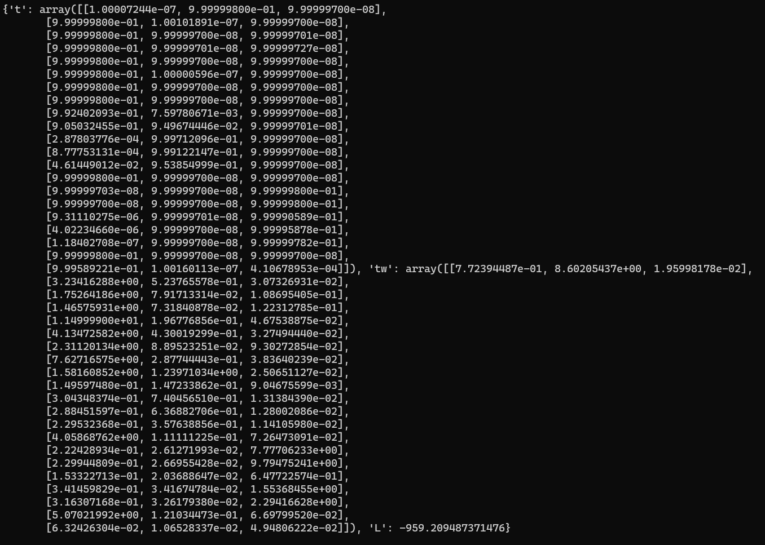

R Results

